Answers
Task 1
The following table shows features of traditional currencies and digital currencies. For each feature, tick whether it is part of traditional currencies and/or digital currencies. You may tick more than one box for each feature if appropriate.
 | Traditional currencies | Digital currencies
May use notes
It may be used to buy and sell products
It may use digital numbers stored on a computer | (Banks mostly operate digitally, however, the numbers in accounts are backed by notes in a central bank)
May use coins
It may be reused multiple times
Has no intrinsic value in itself
It makes use of cryptography to prevent unauthorised transactions
Counterfeit currency cannot be created
A government, central bank, or organisation can decide to make more currency
Counterfeit currency could be created if someone worked out how to break the encryption method. In this case, it is likely that the entire digital currency would fail. Equally, if someone could create more than 50% of the verifying computers on the network, they could verify fraudulent transactions.
Current digital currencies do not allow government/central banks to create more currency and no other person or organisation can create more money. Some digital currencies will, as part of the protocol, create more currency in a pre-defined manner. It is possible for a digital currency to allow an organisation to control it and create money. This may form part of future central bank digital currencies that are currently in development.

Task 2
Before completing this task, please be aware that the bitcoin wallet that you generate must not be used for storing bitcoin. This is because a number of security precautions have not been taken.
Private keys need to be stored very securely as all bitcoin may be stolen if it is revealed. As we are asking for the private key to be pasted into this document, it is far from secure.
Go to https://bitaddress.org
Move your mouse to create a bitcoin wallet and then answer the following questions.
1. Why do you need to move your mouse around?
To make the number more random.
In more detail: normally random numbers are made on computers via pseudorandom numbers. These are fine for computer game opponents and similar uses. However, it is possible for hackers to work out how a pseudorandom number was generated. The mouse movements are used to create true random numbers. The exact position you move the mouse to, will be genuinely random.
2. Paste your bitcoin address below.
An example:
1Bbc8te2XMxghntkr1PdPe76cYUQ13Cpzh
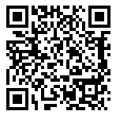
3. Paste your private key below.
L4evrLnJnnYiYBm4NTvfa2KHDn1BF1vTU3xoB5DYD4MbpFYFpgQE
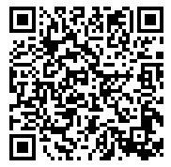
4. What is the purpose of the bitcoin address? (This may be more obvious if you click the button to show a ‘paper wallet’.
Other people may send bitcoin to the bitcoin address. This address may be made public.
5. What is the purpose of the private key?
The private key should be kept secret. It is used to spend bitcoin.
Task 3
Go to:
https://www.blockchain.com/btc/block/000000000019d6689c085ae165831e934ff763ae46a2a6c172b3f1b60a8ce26f
This website allows you to view the contents of blocks on the blockchain.
Block 0 is special. It is the first block on the bitcoin blockchain and is known as the ‘Genesis Block’.
(a) Each block needs to store a timestamp of when it was added to the blockchain.
Using the details of the blockchain explorer, find the timestamp for the very first bitcoin added to the block.
2009-01-03 18:15
18:15 on 3rd January 2009.
(b) The block’s hash is a unique number that identifies each block. Copy below the hash of the first every bitcoin block on the blockchain.
Hash: 000000000019d6689c085ae165831e934ff763ae46a2a6c172b3f1b60a8ce26f
(c) Now look at the transactions that occurred at the following bitcoin address:
https://www.blockchain.com/btc/address/1A1zP1eP5QGefi2DMPTfTL5SLmv7DivfNa
We have no information about who owns the bitcoin address, but we do know every transaction that it has made.
Look at the list of transactions and screenshot and paste one transaction below.
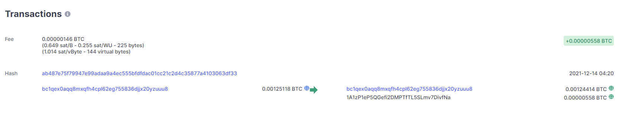
Identify the following details in the transaction by completing the table below:
Transaction details | Values stored in the blockchain ledger
The transaction hash ID
The timestamp | 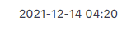
The sending address, or sending addresses
The receiving address, or receiving addresses
The amount of bitcoin transferred | 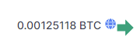  0.00124414 BTC went to the first account and 0.00000558 BTC went to the second account.
The fee to validate the block | 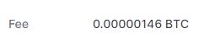
(d) Find the exchange rate of one bitcoin in pounds sterling (British pounds). You can probably use a web browser with the following query:
“1 BTC in GBP”
At the time of writing one bitcoin is 35524.62 GBP.
(e) In pounds, what was the fee charged for processing and verifying this transaction?
Answers will vary. For this example:
0.00000146 * 35524.62 = £0.0519 (or about 5 pence).
(f) International payments of money typically use the SWIFT payments system. UK banks typically charge a fee of around £20 for this service which takes one day to process.
Compare the use of bitcoin in making this transfer.
Answers will vary. For this example:
The cost of transfer with bitcoin is 5 pence, which is significantly cheaper than the CHAPS system. Bitcoin transfers will typically be verified in 10 minutes, which is far faster than 24 hours.

